**Routine Paperless AO Guide**

***\*\*\*\*\*Remember this only applies to routine AOs that you would normally put on line 5\*\*\*\*\****

* Line 5 AO process works as normal until the established cut off time of the day.
  + This is not the process for STAT AOs
  + This is not the process for In-Transit AOs
  + This might affect other AO processes not listed, when in doubt use good judgment and/or ask a lead.
* After line 5 AO is closed for the day each CSR is responsible for writing their own AO requisitions and printing them to the *“To Be DE”* folder until **4pm**.
  + Instructions on how to print to a folder has its own section bellow.
  + F:\To Be DE or \\uscplatxdfs002p\ePHI\To Be DE you should have access to these folders.
  + Pin the folder locations to your quick access panel. This will save you time.
  + Remember we are not printing to a printer so patient insurance cannot be See Attached. You will need to either fill out the insurance, make a screen shot of insurance and add it to the requisition, or write To Follow and following day get the new accession number and send the attachment to the *“Scanning Folder”* mentioned below
* After 4pm each CSR is responsible for writing and data entering all their AOs and printing to the *“Scanning Folder”* formally known as the *“CSR DE Complete”* folder.
  + Date 03/16/2023 folder is still the *“CSR DE Complete”* I am unable to change the name at this hour.
  + F:\Customer Service\CSR DE Complete or \\uscplatxdfs002p\ePHI\Customer Service\CSR DE Complete is the folder location.
  + Do not print in the folders that are labeled as the months; those files are back copies that have already been sent to scanning.
  + Pin the folder locations to your quick access panel.
  + All files must have a barcode in the top right corner of the page. You cannot submit files where the accession number is only typed out it needs to have a barcode. Use <https://www.barcodesinc.com/generator/index.php> and follow the previous guide on instructions.
* Rejoice for you have successfully completed our larger and more unique paperless procedure!

**How to Print to a Folder**

The following steps are to be followed when a file is ready to be data-entered or sent to scanning.

* Select Print and a printing preferences window will appear.
* Select the “Microsoft Print to PDF” printer in the printer selection window

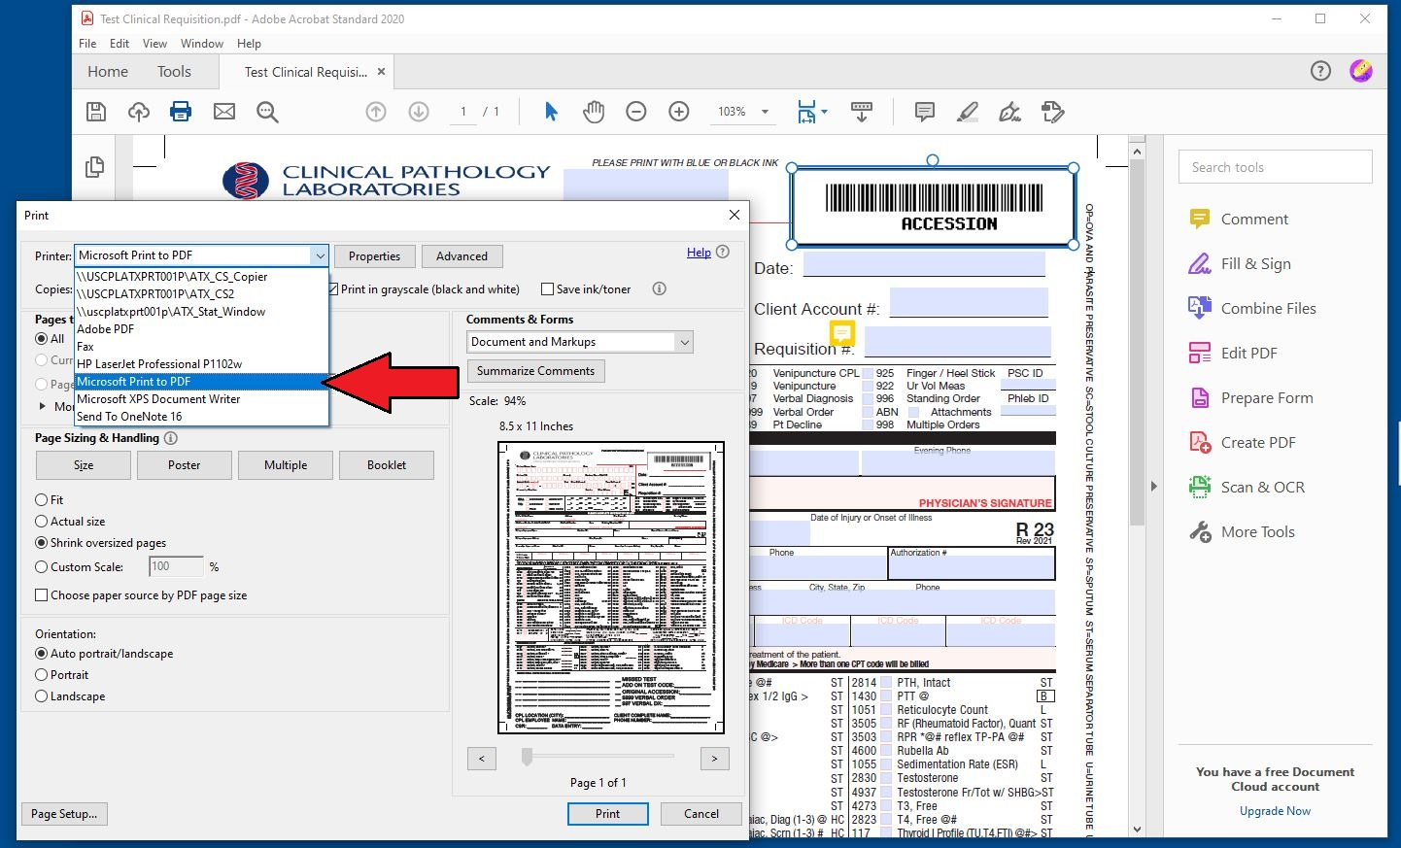

* Make sure that the “Print in grayscale (black and white)” is selected

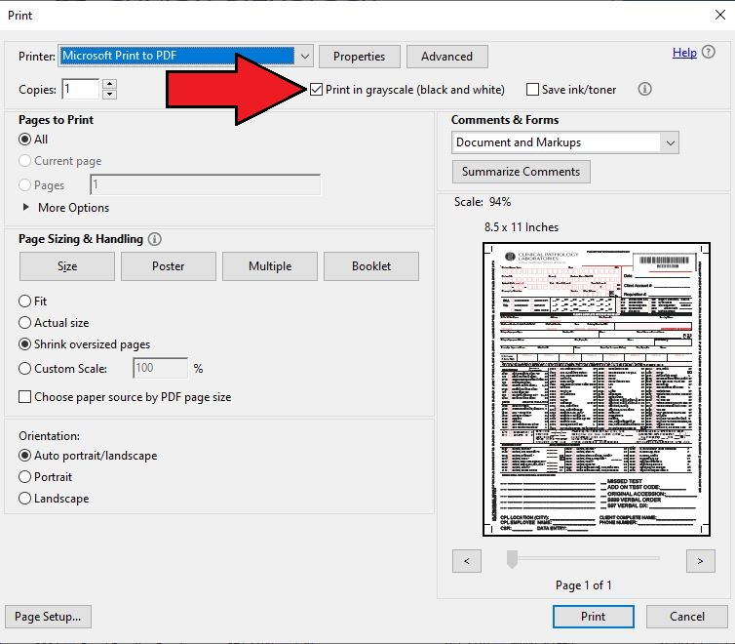

* When you print the document a save prompt will appear and save it with the original accession number in the appropriate folder.

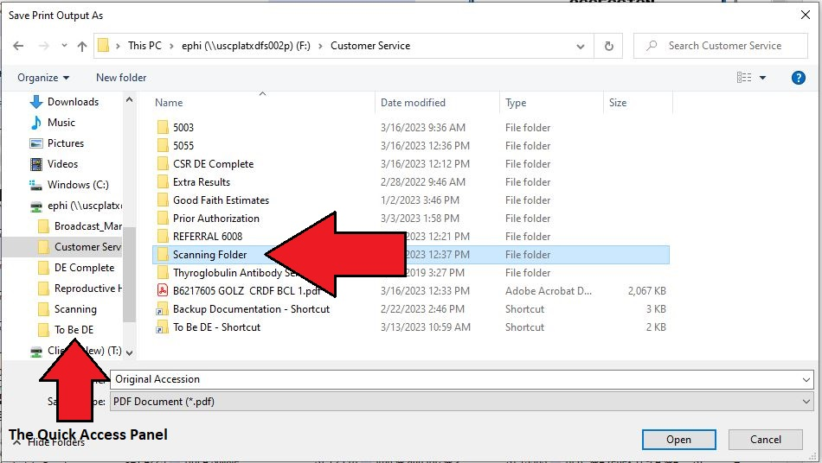

TMI: The reason we have to print are due to limitations of technology. First part is that Scanning department cannot accept or scan images that are in color. The scanning department also doesn’t use PDF files they manually convert them to the correct format for SCERIS. The second reason majority of our files are form filled formatted and during the conversion to get the correct format the fillable sections of the pdf gets erased or overwritten. The fillable fields needs to be locked before we can convert the file.